# **PROBLEM**

Low vision students do not have adequate resources and support to pursue degrees in science, technology, engineering, and math (STEM). Across the country, there are over 3.5 million adults, age 16 to 64, with a visual disability. Only 14.9% of them possess a bachelor’s degree, which falls far short from the 33% of Americans over all who have a bachelor’s degree. The majority of today’s high-paying careers require degrees or experience in STEM fields. Compared to students without visual impairment, it is far more difficult for visually impaired students to pursue STEM degrees.

There are many barriers preventing low-vision students from obtaining STEM degrees. Generally, teachers are not well trained or prepared to teach partially sighted learners (NCBI). Additionally, scientific content often includes technical language and annotations that screen readers cannot recognize or translate. Likewise, writing scientific content and diagrams poses a significant challenge, depending on the severity of a student’s vision impairment. Also, it is more difficult for the vision impaired to actively participate in demonstrations and hands-on activities that rely heavily on sight. Finally, graphs and diagrams are central to the understanding of STEM disciplines, but there are very few technologies geared toward translating graphs and diagrams into a format that low vision students can understand, and cost is often a deterrent to these device’s availability (STANFORD). Together, these barriers discourage low-vision students from obtaining STEM degrees, ultimately resulting in their exclusion from many of today’s high profile careers.

We chose to design a solution that helps low-vision college students affordably see and understand graphs and diagrams in a lecture setting. If low-vision students had the resources allowing them to understand visual content, such as graphs and diagrams, at the same pace as their unimpaired peers, they would be more likely to successfully pursue STEM degrees. Add more details maybe?

Assistive technologies and services that already exist, including screen readers, magnifiers, and personal assistants, fail to solve this problem because they are geared more toward reading and browsing, rather than analyzing complex graphs and diagrams. One example is the PIAF Tactile Image Maker, a device that prints documents on special paper with special ink to produce a raised print that can be touched (PIAF). This device costs $1400, and paper is $140 for 100 sheets - unsustainably expensive for regular use. Additionally, the printer is bulky and impractical for use in a lecture hall setting; it is also likely that a vision impaired user would need another person’s assistance to print. Numerous screen magnification systems exist, ranging from software to physical magnification screens. These solutions are all expensive, costing hundreds to thousands of dollars, and they often have steep learning curves (AFB). Finally, there is personal assistance, where someone else helps read and understand text and media. This solution is the most expensive, because users consistently pay trained professionals for assistance. Additionally, information could easily be lost in translation, particularly if the assistant is unfamiliar with the subject matter or notation. None of these aforementioned solutions are specifically designed for lecture slides to be used in a lecture hall, nor are they designed specifically for technical diagrams and graphs. Our solution will cater toward this small user group, and it will be designed with low monetary cost in mind.

# **SOLUTION**

**Overview**

We have created an application optimized for tablet devices that is integrated with Canvas that helps low-vision students pursuing science, technology, engineering, and math (STEM) degrees navigate through diagram-heavy lecture slides. Because the application is integrated with Canvas, new users log in with their UW NetID, allowing classes and lecture slide files to be pulled into the application. This way, students go through minimal setup, and instructors simply upload lecture slides to canvas before lecture, as they normally would.

The application thus requires permissions to obtain and reformat data from canvas. This includes general course information: the course name, course code, and the quarter taken; as well as instructor-uploaded files for each course.

## **Features & Algorithmic Functionality**

**File Scanning**

Files are scanned for text and diagrams, then modified into a usable format:

* All text, including text that is part of an embedded image, is identified and converted to plain text.
* Diagrams and graphs are identified and vectorized

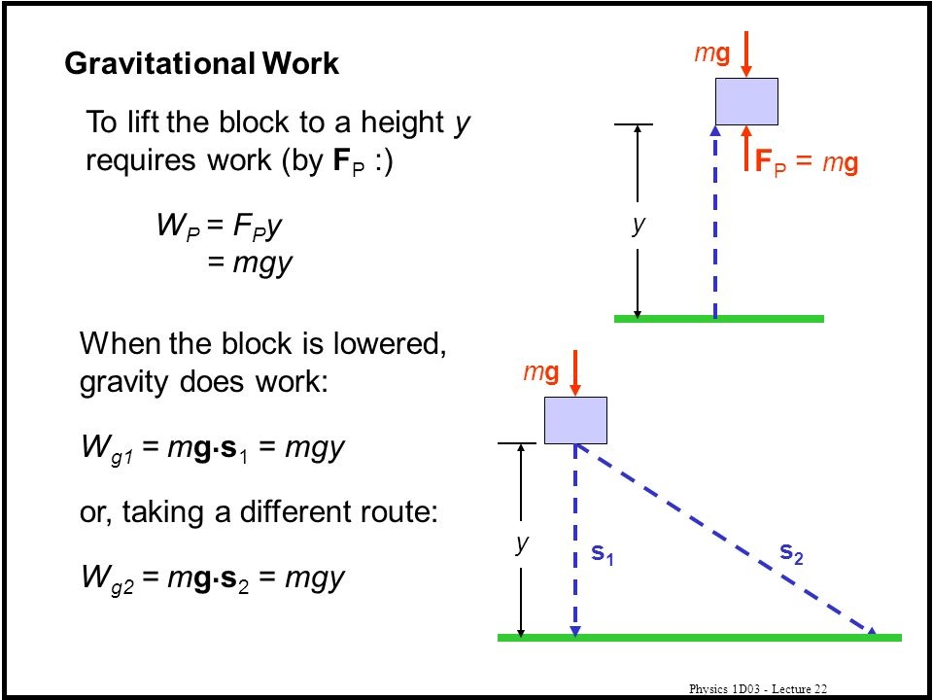

For example, if Figure 1 were a page in a PDF file, the scanning algorithms would convert all of the text, including the red labels, into plain text that can be read by a screen reader. The two diagrams would be vectorized for two reasons: first, so that users can zoom into them without compromising image quality, and second, so that shapes and lines can be described by a screen reader. The scanning algorithms also recognize mathematical and scientific notation and symbols so that they are properly translated by a screen reader. The appearance of the reformatted slides will not change.

Reformatted files may be opened and viewed by users. There are two tools: screen reading and magnification.

**Screen Reading**

The screen reader simply reads text and describes diagrams and graphs. Text is read left to right, top to bottom, and it is highlighted and magnified as it is being read.

**Magnification**

Users can press and hold anywhere on the screen to magnify the area. This way, users can still see how the magnified item(s) fit in with the rest of the content. By dragging while holding, users can move the magnifier around and see different parts magnified. See the application screens for further clarification.

## **Application Screens**

# **EVALUATION**

## **Limitations**

Our project’s greatest limitation was our inability to collect information in context. This includes interviews, user testing with our intended user group, and statistical information collection. We reached out to the University of Washington (UW) Disability Resources Center and the Accessible Technology Office. The Disability Resources Center was unable to provide us with the information we needed, nor could they connect us with vision impaired students, given our short project timeline. They referred us to the Accessible Technology Office, where we hoped to learn more about assistive technology available to vision impaired students at the university, but they never responded to our messages. As a result, we do not know anything about vision impaired student demographics at the UW, including how many there are any what degrees they are pursuing. We also have limited information on the technologies specifically available for UW students and what struggles these students face in terms of assistive technology. Instead, our research is based on national data and studies that address the accessibility of STEM fields to the visually impaired. Our user testing was conducted on students without glasses, who would be visually impaired, if not for their glasses. This means that our design may not fit the needs of students that are lower on the spectrum of low vision.

Because our solution relies on Canvas integration, users can only retrieve files from Canvas; they cannot download files externally or import files from other sources. Our solution makes the assumption that professors will upload their lecture slides and handouts to Canvas. As a result, this limitation prevents users from using the application with media that professors refer to during lecture, such as websites and documents not hosted on Canvas.

Our design does not work for non-English speaking students because lecture slides are not translated to other languages, and the voice recognition only detects English. Additionally, if there are images on the slides, the screen reader will not be able to describe it; however, users can zoom into it.

MORE LIMITATIONS.

## **References**

Maguvhe, M. (2015). Teaching science and mathematics to students with visual impairments: Reflections of a visually impaired technician. African Journal of Disability, 4(1), 194. http://doi.org/10.4102/ajod.v4i1.194

PIAF Tactile Image Maker. (n.d.). Retrieved March 2, 2018, from http://piaf-tactile.com/piaf/

Sawhney, K. (2014, Winter). STEM Access for the Blind and Visually Impaired [Scholarly project]. In Perspectives in Assistive Technology. Retrieved March 2, 2018, from https://stanford.edu/~kartiks2/stem-access.pdf

Screen Magnification Systems. (n.d.). Retrieved March 2, 2018, from http://www.afb.org/prodBrowseCatResults.aspx?CatID=39

American Foundation for the Blind